Agregar productos con series

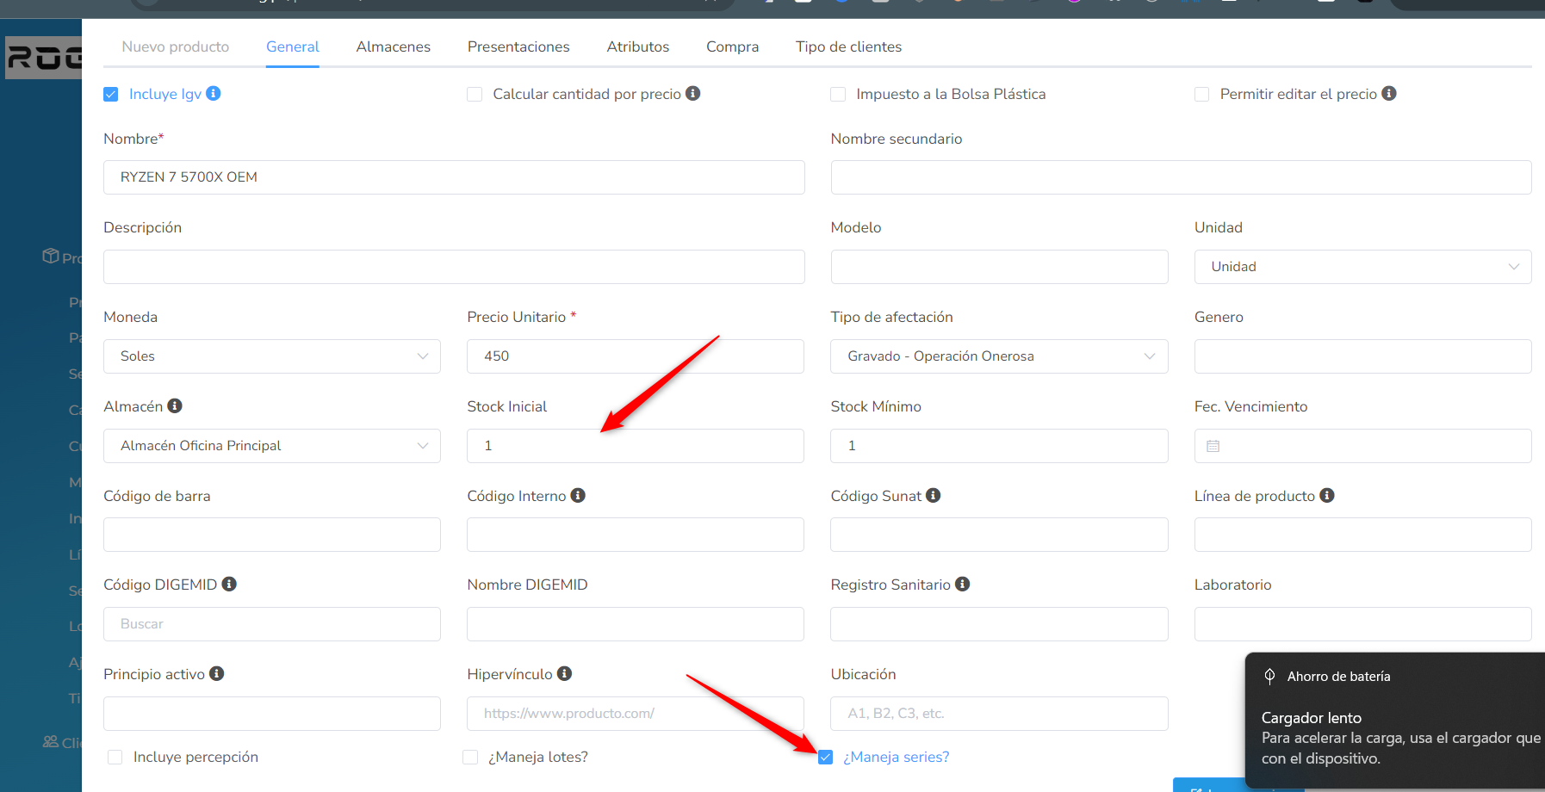
Video
https://www.youtube.com/watch?v=xSm9hS52HXE

